

The Play Box
Hamsters are renowned for disappearing into small spaces and gnawing anything and everything they find, so letting a hamster run free, however well supervised can lead to problems. They have the ability to climb up inside furniture and squeeze into spaces we humans would consider far too small for them. A gnawed electric cable can not only be expensive to repair but could be very dangerous for the hamster.
However big your cage may be, a hamster does enjoy space to run “free” and explore. A simple way to achieve this, both for your enjoyment and your hamsters is to build a play box. This will not only give your hamster space to run around but also ensure that it cannot cause damage or escape whilst doing so.
A simple play box can be made from a large cardboard box in which a fridge, washing machine or television comes in. It should be about 100 cm by 60 cm and approximately 30 cm high to give your hamster plenty of running space. The box can be held in shape using bulldog clips so that when not in use can be folded flat to store.
This on its own would be rather boring so why not make some “toys” to go in it. A large shoebox with holes in the sides to enable cardboard tubes to be pushed in makes a simple maze. Cardboard egg cartons, with a little food in each dimple will keep your hamster exploring for some time. A clean plastic drinks bottle (2 litre size or bigger) with the top and bottom cut off and the edges sanded smooth makes a lovely tunnel. Commercially made toys can also be used in the box such as seesaws and plastic and wooden blocks.
When placing any of these in the play box ensure that none are too close to the sides thus encouraging and enabling your hamster to climb out. Although you can leave your hamster in the play box for some time it should not be left unattended for too long as cardboard can be chewed through allowing your hamster yet another escape route. Thick cardboard boxes that we have used have normally lasted for several weeks before needing to be replaced even when used by litters. However, if used by a single hamster the cardboard box should last many months. You will find that the corners are the first to be chewed and one way to extend the life of the box is to place a large washed stone in each corner, not too large as these may also act as stepping stones to the outside world. A more “permanent” play box can be made from a large plastic storage box.
An extract from HAMSTER LOPAEDIA - By Chris & Pete Logsdail by kind permission of Ringpress ISBN 1 86054 246 8

THE BUCKET TRAP

Should your hamster escape then placing the cage on the floor with the door open near where the hamster may be, usually results in the hamster taking the bedding and food to its new den. This, of course, means that the hamster although warm and well fed, is still on the loose. The most effective way to “capture” an escapee is the bucket trap, which is successful 9 times out of 10.

A tall bucket set at a steep angle propped up and supported by books or bricks with more of the same as a stairway to the top of the bucket makes an excellent trap. If using books, please ensure that they are not your favourite reading material as your hamster could collect more “bedding” on the way and so spoil future reading. Some shavings, bedding, Hamster Mix and strong smelling greens complete the set up of this trap. The hamster is drawn by its strong sense of smell to food and water or in the case of the bucket trap to the greens, which will supply the moisture. Broccoli and cabbage are quite odorous and are excellent for this purpose. The hamster will climb the “stairs” and slide into the bucket to get to its prize.
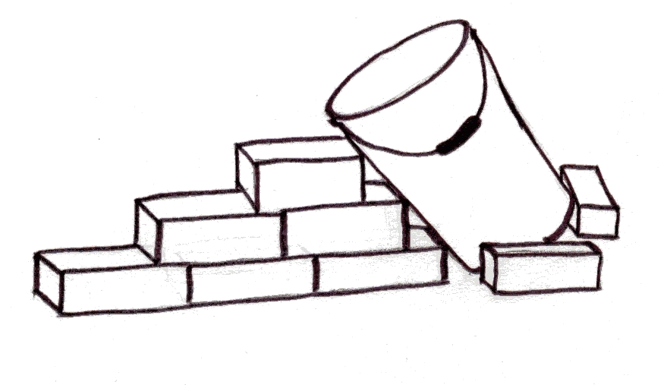
Once inside the bucket it will be unable to gain purchase on the smooth sides of the bucket (if the bucket is placed at a steep enough angle) to climb out again so the bedding, food and small amount of shavings encourage it to settle down to sleep without causing it too much stress. A word of warning must be given at this stage however, that if you have a cat or dog in the household, they must be restrained from being able to enter the room in which the bucket trap is set up.

Chris & Pete Logsdail

The Play Box
Hamsters are renowned for disappearing into small spaces and gnawing anything and everything they find, so letting a hamster run free, however well supervised can lead to problems. They have the ability to climb up inside furniture and squeeze into spaces we humans would consider far too small for them. A gnawed electric cable can not only be expensive to repair but could be very dangerous for the hamster.
However big your cage may be, a hamster does enjoy space to run “free” and explore. A simple way to achieve this, both for your enjoyment and your hamsters is to build a play box. This will not only give your hamster space to run around but also ensure that it cannot cause damage or escape whilst doing so.
A simple play box can be made from a large cardboard box in which a fridge, washing machine or television comes in. It should be about 100 cm by 60 cm and approximately 30 cm high to give your hamster plenty of running space. The box can be held in shape using bulldog clips so that when not in use can be folded flat to store.
This on its own would be rather boring so why not make some “toys” to go in it. A large shoebox with holes in the sides to enable cardboard tubes to be pushed in makes a simple maze. Cardboard egg cartons, with a little food in each dimple will keep your hamster exploring for some time. A clean plastic drinks bottle (2 litre size or bigger) with the top and bottom cut off and the edges sanded smooth makes a lovely tunnel. Commercially made toys can also be used in the box such as seesaws and plastic and wooden blocks.
When placing any of these in the play box ensure that none are too close to the sides thus encouraging and enabling your hamster to climb out. Although you can leave your hamster in the play box for some time it should not be left unattended for too long as cardboard can be chewed through allowing your hamster yet another escape route. Thick cardboard boxes that we have used have normally lasted for several weeks before needing to be replaced even when used by litters. However, if used by a single hamster the cardboard box should last many months. You will find that the corners are the first to be chewed and one way to extend the life of the box is to place a large washed stone in each corner, not too large as these may also act as stepping stones to the outside world. A more “permanent” play box can be made from a large plastic storage box.
An extract from HAMSTER LOPAEDIA - By Chris & Pete Logsdail by kind permission of Ringpress ISBN 1 86054 246 8

THE BUCKET TRAP

Should your hamster escape then placing the cage on the floor with the door open near where the hamster may be, usually results in the hamster taking the bedding and food to its new den. This, of course, means that the hamster although warm and well fed, is still on the loose. The most effective way to “capture” an escapee is the bucket trap, which is successful 9 times out of 10.

A tall bucket set at a steep angle propped up and supported by books or bricks with more of the same as a stairway to the top of the bucket makes an excellent trap. If using books, please ensure that they are not your favourite reading material as your hamster could collect more “bedding” on the way and so spoil future reading. Some shavings, bedding, Hamster Mix and strong smelling greens complete the set up of this trap. The hamster is drawn by its strong sense of smell to food and water or in the case of the bucket trap to the greens, which will supply the moisture. Broccoli and cabbage are quite odorous and are excellent for this purpose. The hamster will climb the “stairs” and slide into the bucket to get to its prize.
Once inside the bucket it will be unable to gain purchase on the smooth sides of the bucket (if the bucket is placed at a steep enough angle) to climb out again so the bedding, food and small amount of shavings encourage it to settle down to sleep without causing it too much stress. A word of warning must be given at this stage however, that if you have a cat or dog in the household, they must be restrained from being able to enter the room in which the bucket trap is set up.

Chris & Pete Logsdail

