Housing
A useful cage, used by many breeders, is the type comprising a "cat litter" tray with a wire top clipped to it. Hamsters love climbing and will get plenty of exercise in this type of cage. There are also on the market the all or nearly all plastic cages, comprising a number of compartments linked by tubes. These cages do come into their own if you also own a cat or dog as the hamster is protected against claws.

A good layer of sawdust or shavings should be spread on the floor of the cage to absorb the urine. If you are keeping long-haired hamsters then sawdust is preferable. NEVER, NEVER put newspaper under the sawdust, as chewing this could lead to poisoning. Shredded paper bedding is safest for the hamster’s nest.

Food dishes can be used but scattering food around the cage encourages the hamster to forage as it would in the wild. It will pouch the food and store it somewhere in the cage, satisfying it’s instinct to hoard.

Care should be taken when positioning the cage. Do not place in direct sunlight and make sure it is out of draughts and away from radiators or fires as extremes of temperature are harmful.

Cages should be cleaned about once a week but food and water should be checked daily to ensure that your hamster is healthy and happy. In the end, whatever type of cage you use, please remember to handle your hamster daily and, above all, enjoy your pet.

Dwarf hamsters, because of their small size, may squeeze through the bars of “hamster” cages. They may be kept in “mouse” cages with spaces of no more than 1cm between the bars. They do live very happily in glass tanks with wire lids (small gauge mesh) and in plastic tanks with inter-connecting tubes.

Feeding
The major part of the diet should be a complete hamster mix which can be bought from a pet shop. This will be a mixture of seeds, crushed oats, flaked maize, sunflower seeds, locust beans, peanuts etc. with some hard dry biscuit. All these are "hard foods" and gnawing them is good for the hamster's teeth, (which grow throughout its life). A small handful of this mixture should be given each day and fresh water, (preferably in a bottle), should always be available.

As hamsters put their food into their cheek pouches "sticky" and "sharp" foods should be avoided. Chocolate (which can melt when pouched) and cornflakes (which can scratch the pouches) are two such foods.

Greens and other supplements
Carrots, cabbage, cauliflower, broccoli, sprouts, broad beans, peas, runner beans, apple, bean sprouts, sweet corn, cucumber and cooked potato can all be given in small quantities, i.e. a slice of apple OR a small floret of cauliflower, OR a small sprout, OR two broad beans would be enough at any one time. A very special treat would be a raisin or sultana. All greens should be fresh and washed.

To help your hamster grow strong bones and teeth some milky foods can be given. Some will enjoy milk on its own, others a little runny porridge, a few rice krispies with milk or even bread and milk, (all without sugar of course). Any of these should be removed before the milk sours, if they are uneaten.

All species of hamster may be fed as above, but dwarf hamsters (Russian, Chinese etc) will appreciate the addition of tiny amounts of smaller type of seed – e.g. millet, budgie seed or foreign finch seed.

Health Issues
Hamsters are normally healthy little beasts, living to about two years with little problem. Things to watch out for include wounds or lumps anywhere on the body, wheezing, coughing or sneezing, loss of appetite or diarrhoea.

If you see these symptoms, or are concerned about your pet, contact your local Veterinary Surgeon, who will provide you with all the medical help and advice that you need.
Handling
When you get your hamster home, leave the hamster overnight to settle down and get used to its new cage. Talking quietly to your hamster will help it get used to your voice.

Always approach the hamster gently with no sudden moves, so as not to scare it. If it is asleep, gently tap the cage or nest to wake it up, and let it walk out of its nest. Never just grab the hamster while it is asleep in its nest. You will startle it and it might bite you in fear.

Initially it is a good idea to remove the top part of the cage. Place the cage inside a large box first, so the hamster cannot run away. To pick up your hamster, place one hand firmly but gently around its body or cup both hands together and lift your hamster up. Either way is suitable, whichever you find the easiest.

Lift the hamster gently just a few inches from the cage, so if it jumps out of your hands it will not hurt itself. Speak gently as you handle your hamster and stroke it gently but avoid touching its head.

If it struggles to escape your grasp place it back down and a few seconds later pick it up again. Repeat this process until it feels secure in your hand. Once it knows that you are not going to hurt it, you will both become more confident and you will find your hamster waiting to come out to be handled.

It is a good idea not to give your hamster a house for the first few weeks as this can make encouraging the hamster out more difficult. Once the hamster comes to your voice the house can be introduced should you so wish.

Always make sure your hands are clean before handling your hamster. They cannot see very well and rely on their sense of smell. If you have been eating anything nice, the hamster may nibble your finger, thinking it is something to eat!

Finally as a matter of hygiene always wash your hands again once you have finished handling your hamster.



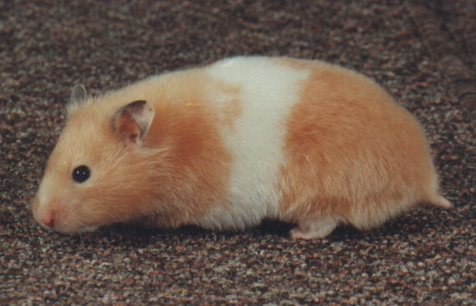

Caring for your hamster

This leaflet is supplied free by the National Hamster Council.
It contains information to help you look after your new hamster.

If you need more information, please visit our websites at

National Hamster Council - www.hamsters-uk.org

Midland & Southern Hamster Club
www.mashamster.club

Northern Hamster Club
www.northernhamsterclub.com

or write to
National Hamster Council Secretary
6. Winchcombe Road, Alcester,
Warwickshire, B49 6QL

